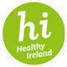

**Healthy Ireland News**

***Mental Health***

**Stress Control Programme**

* Stress Control is a six week Saolta staff led programme empowering participants to manage stress and increase coping skills. This year the Stress Control Programme completed its third year of delivery with over 2000 attendees participating to date. Autumn courses in Galway were booked out with an average of 40 people attending each session. In 2020 Saolta will be recruiting additional Stress Control trainers across the group. MUH Principal Social Worker Seamus Moran was the first hospital staff member to be trained as a master trainer for Saolta in September2019 and will train our new staff.
* Group facilitators:

GUH- Rachel Macken, Maeve Tonge, Anne Smyth, Ann Marie Newell, Brid Gavin O’Connell, Marie Tierney, Shirley Kilroe

PUH- Ann Igoe, Patricia Blighe

RUH- Ann Igoe, Patricia Blighe

SUH- Angela Mohan

MUH-Seamus Moran, Angela Blendell

LUH- delivered via the Majella O’Donnell Foundation

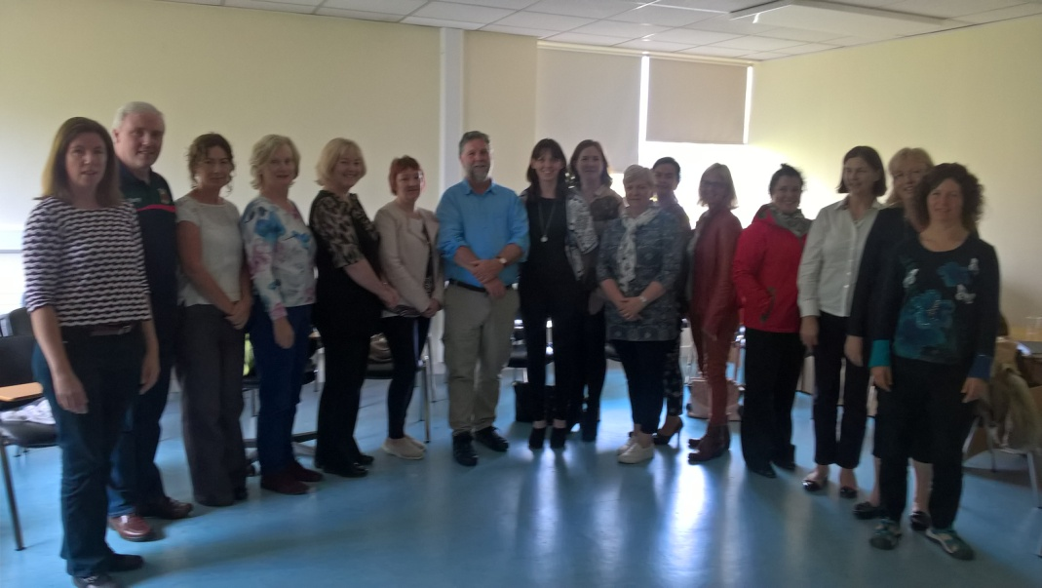

*Saolta Stress Control Trainers with Stress Control founder Dr. Jim Whyte*

**Mindfulness**

* Sessions continue across the group with several hundred staff attending. In 2020 Saolta is aiming to offer a standardised bespoke training programme for existing trainers and to recruit new trainers with a view to expanding the programme.

**Hospital Choirs**

* Six choirs perform across the group with performances having taken place in theatres and at national events. CD’s have been produced by some choirs.

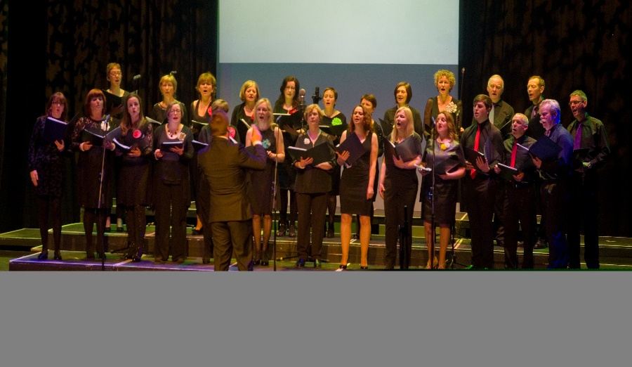

**Arts**

* 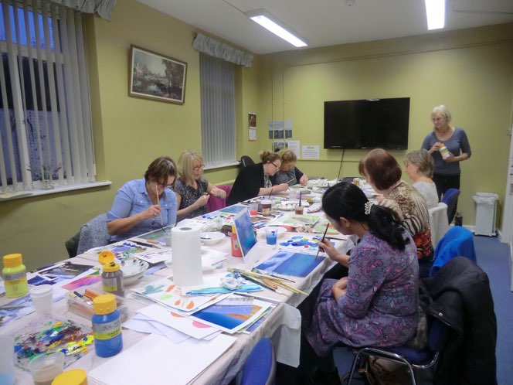The Saolta Healthy Ireland fund continues to support various Arts initiatives across the group including hospital environment enhancements, staff and patient poetry and art classes. 

***Training and Education***

**Making Every Contact Count (MECC)**

* The Making Every Contact count Framework was launched across the group with a number of sites engaging in pilot programmes.
* MECC is an online and face to face training programme enabling staff to develop brief intervention skills that can facilitate behaviour change in patients in areas such as smoking, alcohol consumption and weight management.
* Staff can complete the accredited online training at any time via <https://www.hse.ie/eng/about/who/healthwellbeing/making-every-contact-count/training-programme/>

**Saolta Health and Wellbeing Training plan**

* The Saolta Health and Wellbeing Training plan outlines resources for staff in the areas of training, personal support and patient support. The plan can also be used as a resource in supporting the Making Every Contact Count Framework. The plan can be accessed [here](http://www.saolta.ie/documents/saolta-health-and-wellbeing-training-plan).

**Saolta Healthy Ireland fund and National Healthy Ireland fund**

* A number of initiatives were supported across the group. These include:
* Places on the NUIG Workplace Wellness Course
* Healthy Ireland merchandise
* Arts programmes
* Smoking cessation signage and workshops
* Bereavement booklets launch
* Staff recreation areas
* Hospital choirs
* Pedometer challenge
* Stress control
* Bicycle shed and signage
* Flu vaccine promotion

***Healthy Eating and Active Living***

**Calorie Posting**

* The HSE Calorie Posting Policy was implemented across the Saolta Group with a number of hospitals achieving awards for healthier food offerings.

**Healthier Vending**

* Saolta engaged with the National Nutrition Surveillance Centre and its catering partners to participate in a review of the HSE Healthier Vending Policy. The HSE launched a revised Healthier Vending Policy and as such:
* Vending machines will no longer stock sugar sweetened drinks.
* Snacks containing more than 200kcals per packet will not be stocked in vending machines, with the exemption of three products (nuts, dried fruit and seeds).
* This exemption does not apply to composite items that contain nuts/seeds or dried fruit as ingredients, for example, cereal bars.
* In line with the HSE National Contract for Vending 2015–2020 contracted companies and any other companies with pre-existing contracts still in place must comply with the branding specifications for vending machines.
* Vending machines should only utilise the Healthy Ireland brand as determined by the HSE.

**Bariatric Care**

* Saolta invested in specialist software to enhance patient care at the GUH Bariatric Service in addition to funding the MILIS research to support weight loss for patients.

**Walking**

* Saolta group had 51 teams and 806 participants taking part in the National Steps to Health Challenge this year which took place from May 13th- June 16th.
* Saolta represented 25% of the total participants from hospital groups in the challenge and 8% of overall participation in HSE.
* This was the highest of any hospital group for the third year running and the second highest overall of any HSE organisation.
* [www.hospitalwalks.com](http://www.hospitalwalks.com) outlines numerous walking routes are in place across our hospital sites and these walks continue to be popular for staff and service users alike.

***Flu vaccination***

* The flu vaccine uptake has doubled since 2016 with 41% of staff vaccinated in the 2018/19 season. The role of the flu vaccine committee and the peer vaccinators continue to promote uptake of this vital vaccine.

***Smoking Cessation***

* Saolta provides three dedicated patient and staff services in Galway, Sligo and Letterkenny. Two sites were awarded bursaries of €5000 for their work in promoting smoking cessation.
* The group operates a smoke free campus policy across all sites.

For further information see [www.saolta.ie/hi](http://www.saolta.ie/hi)