Provide Staff Healthy Hearts Morning to support World Heart Day at Letterkenny University Hospital | Introduction:  World Heart Day was celebrated on the 29th of September, 2017 and the Irish Heart Foundation campaign for Healthy Hearts ran throughout the month of September. Heart disease is the “world’s most common cause of death, killing over 17 million per year- 31% of the world’s population, similar to the annual Irish statistics for deaths related to cardiovascular diseases (CVD). Diseases of the heart and blood vessels have multiple risk factors fortunately most are modifiable. Within the Saolta University Healthcare Group Healthy Ireland Plan (2015-17); staff health and well-being are recognised as an area of action for hospitals to target. Letterkenny University Hospital (LUH) is one of the hospitals within this aforementioned healthcare group. To support World Heart Day, LUH delivered a staff healthy hearts session to raise awareness and address modifiable CVD risk factors; blood pressure, cholesterol levels, tobacco smoking, type 2 diabetes- assess random blood glucose level, body mass index (+/- waist circumference), physical inactivity, daily fruit, fibre, saturated fat and alcohol intake.  Primary Aim:  The primary aim of the session was to raise staff member’s awareness of their modifiable cardiovascular (CVD) risk factors by acquiring information to inform positive attitude and behaviour change/s to improve staff members’ overall heart health and well-being.  Objectives:  - Increase awareness of modifiable cardiovascular risk factors to enable staff to identify their own individual risk factors.  - Clinical team to record modifiable risk factors on each individual’s assessment form.  - Clinical team to educate and provide motivational brief interventions with staff on identified risk factors to encourage positive attitude and behaviour change/s.  - Clinical team to signpost or refer staff member to GP/specialist service if risk factor out of normal range or requiring specialist intervention.  Methodology:  An awareness session was arranged on Friday 28th of September from 09:00hrs to 13:00hrs in partnership with the following LUH departments; diabetic, cardiology, dietetic, catering, smoking cessation and the Donegal Medical Academy (NUIG). All grades of staff were informed of the event through the hospital’s email staff group and event posters. Event information advised all staff taking part would be entered into a draw for sponsored food/beverage vouchers.  The session was hosted in the Medical Academy and provided by eight nurse specialists and one student dietician. Blood pressure (manual) and heart rate checks (radial palpation) recordings and education were carried out by the Cardiac Rehabilitation, Stroke and Heart Failure Clinical Nurse Specialists (CNSs). Four Diabetic CNSs recorded random blood glucose levels and provided relevant education on improving diabetic risk and informing on healthy diet choices.  A student dietician recorded body mass indexes (BMI) and waist circumferences (WC). The Smoking Cessation CNS assessed tobacco and alcohol use, BMIs, WCs, dietary intake (recommended intake of fruit and vegetables, fibre and saturated fats), portions sizes, cholesterol levels (if available) and raised awareness of impact of psychological distress on heart health.  Leaflets on all modifiable risk factors were available on tables throughout the venue. The staff assessment form targeted and included recommendations on the following areas; tobacco, alcohol, body mass index, physical activity and blood pressure, on completion staff took these away for their own information. Written consent was obtained from all staff receiving blood glucose recording, while verbal consent was taken for those requesting checks/information on all other modifiable CVD risk factors.  Results:  Over one hundred and twenty staff attended representing thirty one departments, with most availing of face to face encounters with a specialist; 98% (118) completed blood sugar checks; 100% (120) availed of blood pressure and heart rate checks; 83% (100) calculated their body mass index (+/- waist circumference checks; 33% (40) assessed their daily diet (including fruit and vegetable and alcohol intake) and physical activity; 8.3% (10) raised psychological distress as an issue and 10% (12) availed of tobacco cessation information. Referral on or signposting for further intervention included; seven staff were referred back to their General Physician (GP) for further diabetic screening, 6 staff were advised to have blood pressure rechecked and four staff agreed to join tobacco cessation programme. Staff who identified they wanted to make dietary +/- physical activity changes were provided with “Eat Smart Move More Reward Charts” and supporting information. Psychological distress is also identified as a modifiable risk factor and during discussions, ten staff identified this area as an individual risk factor; three staff were signposted to their GP/psychological support services/Occupational Health. Further audit or investigations on the staff recordings are not available; this was not the purpose of the event and individual written consent and organisational ethical approval was not sought for this purpose.  Conclusion:  The event met the overall aim and the identified objectives. Very positive feedback was received from staff attending the event and those staff recording CVD risk factors. Staff requested a similar event be offered to staff annually.  Acknowledgements:  Thank you to all staff who attended the event, making the event a huge success. Your informal feedback was very positive and was greatly appreciated by the team. Thank you to the Donegal Medical Academy for hosting the event, to the sponsors who provided food and beverages and vouchers for 12 individuals. To the team – who in the vested interest of our staff – gave their time to host the event - without a second thought; your time, expertise and support was greatly appreciated.  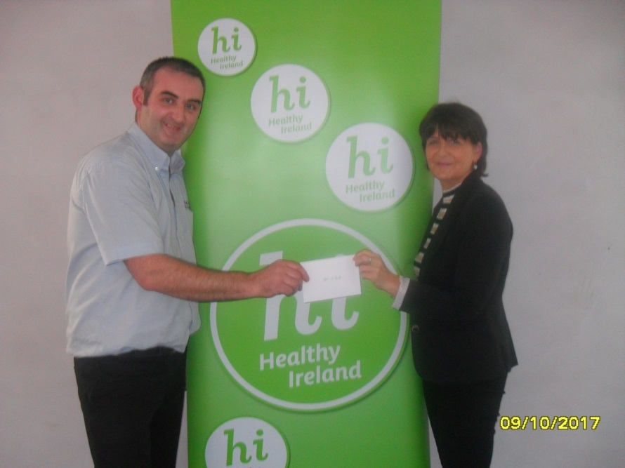  Edward McDevitt was presented with a Lemon Tree meal voucher from Angela McGinley (IMPACT Rep.)  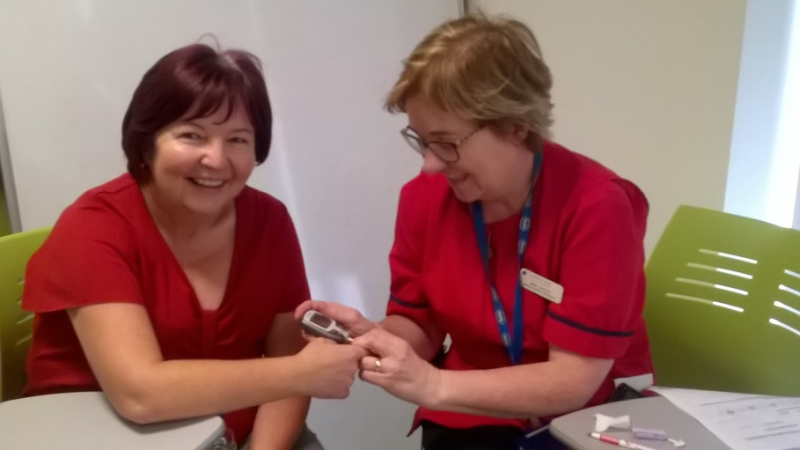  Anne Griffin, Diabetes CNS checking random glucose levels and giving nutrition education  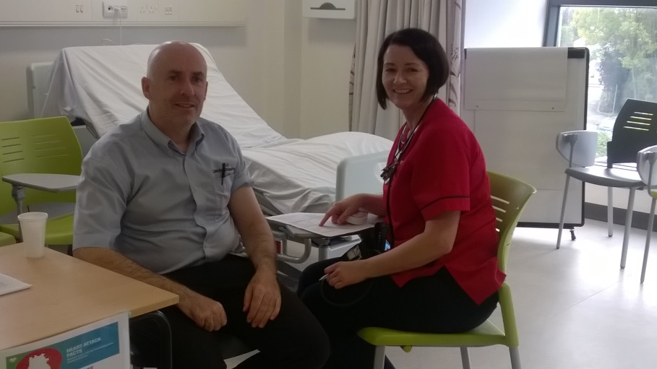  Martina McDaid, Cardiac Rehab. CNS checking manual blood pressures and radial pulses  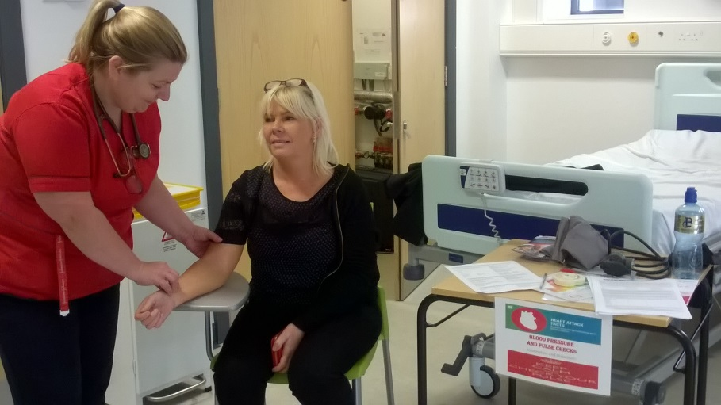  Cathy Farrell, Heart Failure CNS/RNP checking manual blood pressures and radial pulses  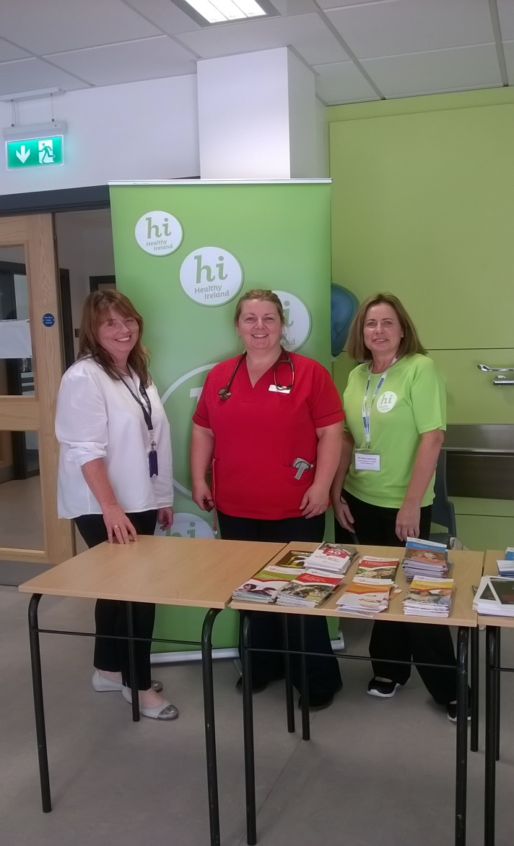  Kathleen Crerand Diabetes CNS, Cathy Farrell, Heart Failure CNS/RNP and Elaine Robinson Smoking Cessation CNS/RNP  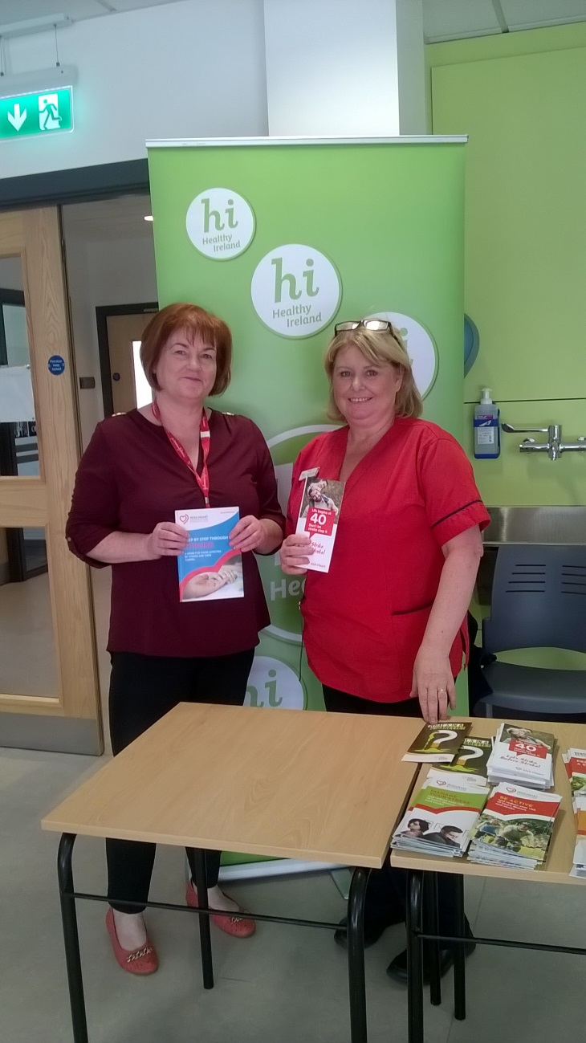  Ann Gavaghan Diabetes CNS, Christine McLaughlin Stroke CNS

